

**Instructions to implement Tapit Ads library in Basic4Android**

Tapit latest SDK implements a new type of ad called AdAlert. See screenshots below.

Step 1)

Register at <http://tapit.com/>, once you are registered create and add new application and choose the type of ad you will be using. You will receive a Zone ID for each type of ad you create.

Step 2)

Download the latest Tapit SDK, Unzip it to a safe location anywhere on your Desktop.

Step 3)

Download the TapitAds_V1.3.jar and TapitAds_V1.3.xml files and copy this files along with the TapitAdView.jar file to your additional libraries folder in C:\Program Files (x86)\Anywhere Software\Basic4android\Additional Libraries.

Step 4)

Copy the “tapit_interstitial_close_button_normal.png” and “tapit_interstitial_close_button_pressed.png” images to the res/drawable folder of your project files and flag them as read only, otherwise Basic4Android will delete this files from the folder everytime. This images are used by the library as the close button images for the interstitial Ads. Do Not rename files!

On the Tools menu in Basic4Android click on clean project before running the application, this causes the two added images to be added to the R.java file.

Step 5)

On the right side of Basic4Android under the Libs tab select the TapitAds_V1.2 library.

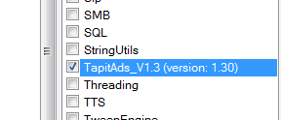

Step 6)

You are now ready and set up to start using Tapit Ads library, follow the example below for more information.

**Tapit Ads Basic4Android example.**

Sub Globals

'These global variables will be redeclared each time the activity is created.

'These variables can only be accessed from this module.

Dim tap As TapitAd

Dim AdAlert, Full_Screen, Interstitial, VideoAd, Offer_Wall As Button

End Sub

Sub Activity_Create(FirstTime As Boolean)

tap.Initialize("Banner", "1234")

Activity.LoadLayout("main")

AdAlert.Initialize("AdAlert")

Full_Screen.Initialize("Full_Screen")

VideoAd.Initialize("VideoAd")

Offer_Wall.Initialize("Offer_Wall")

Activity.AddView(tap, 0, 0, Activity.Width, 100)

End Sub

Sub AdAlert_Click

tap.fireAlertAd("1234")

End Sub

Sub Full_Screen_Click

tap.FullscreenView("1234")

End Sub

Sub Interstitial_Click

tap.Interstitial("1234")

End Sub

Sub VideoAd_Click

tap.videoview("1234")

End Sub

Sub Offer_Wall_Click

tap.offerwall("1234")

End Sub

Sub Banner_loading

Log("Ad banner is Loading.....")

End Sub

Sub Banner_finished

Log("Banner has been displayed!")

End Sub

Sub Banner_failed(error As String)

Log("banner failed to display" & " " & error)

End Sub

Sub alertad_displayed

Log("Alert Ad has been succesfully displayed!")

End Sub

Sub alertad_failedtodisplay(error As String)

Log("Alert Ad has failed to display" & " " & error)

End Sub

Sub alertad_closed

Log("Alert Ad has been closed by user")

End Sub

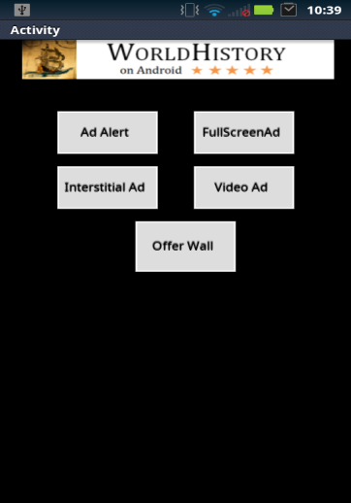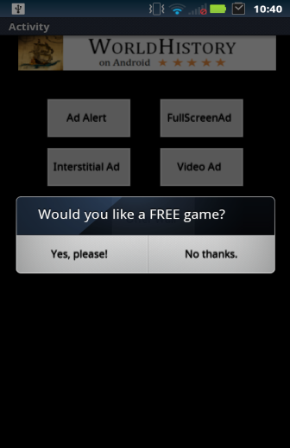  

Banner Ad Ad Alert Full Screen Interstitial

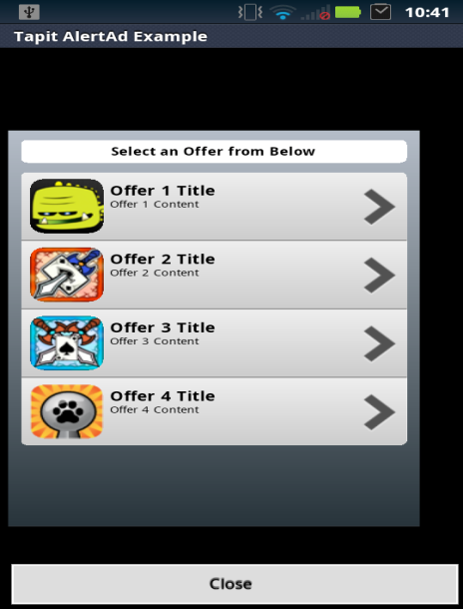

Offer Wall Ads